**SPRINT DELIVERY 3**

**TEAM ID: PNT2022TMID25041**

**WORKFLOW FOR IOT SCENARIO’s USING LOCAL NODE RED**

**NODE-RED:**

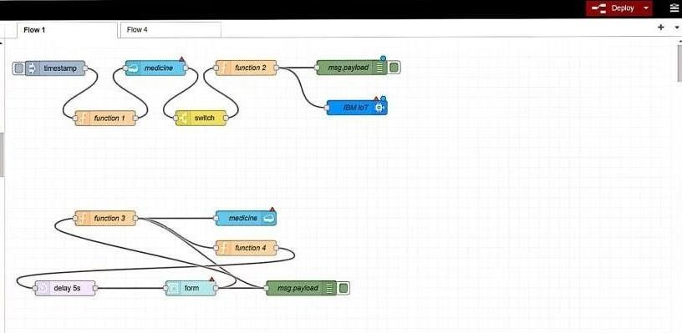

**FORM:**

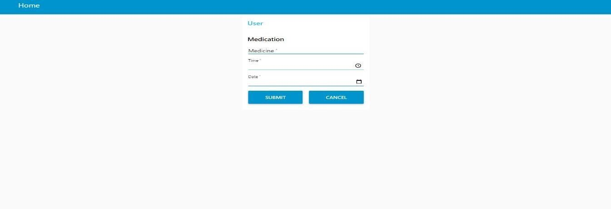

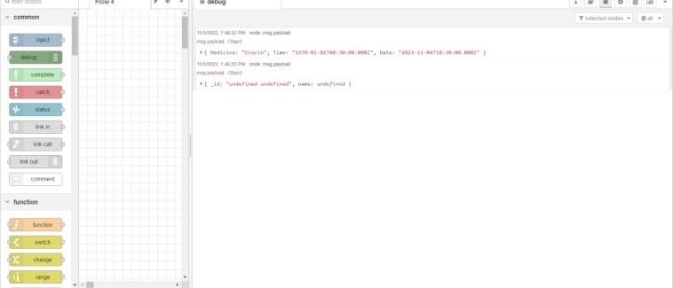

**LOG IN:**

**NODE RED:**

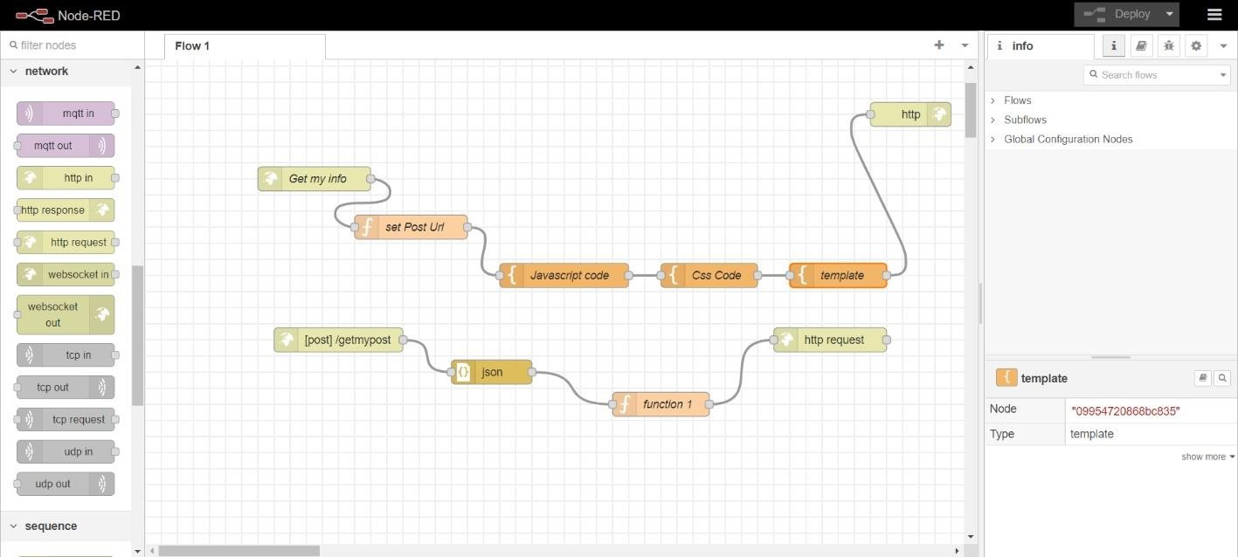

**FORM:**

